**27378 DUDE BALA DURGA SAI SESHU**

**5 testing styles in software**

**System Testing:** This is a comprehensive level of testing that evaluates the entire integrated system. It goes beyond just individual components or their interactions and assesses the system as a whole against its specified requirements. The goal is to ensure that all the different parts work together as expected to achieve the overall objectives.

**End-to-End Testing:** Often considered a type of system testing, end-to-end testing simulates the complete user journey from start to finish. It validates the flow of data and interactions across different components and layers of the application, ensuring that the entire system works correctly from the user's perspective.

**Component Testing:** Similar to unit testing but often broader in scope, component testing focuses on testing individual software components in isolation. A "component" can be a module, a class, or a group of related units. The aim is to verify the functionality and behavior of each component independently.

**Usability Testing:** This testing style focuses specifically on how easy and intuitive the software is for end-users to use. It involves observing real users interacting with the software to identify any usability issues, such as confusing navigation, unclear instructions, or accessibility problems.

**Mobile Testing:** Given the prevalence of mobile applications, this has become a significant testing style. It encompasses testing mobile apps on various devices, operating systems (like iOS and Android), and network conditions. It considers factors like responsiveness, performance on different hardware, battery consumption, and user experience specific to mobile interactions.

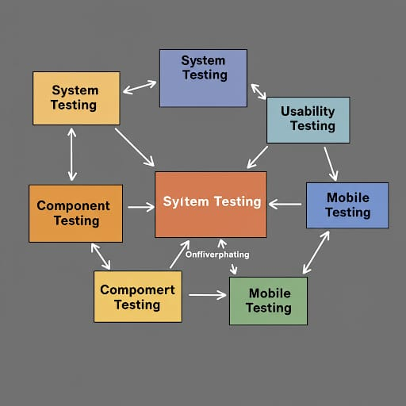

**illustrating the five software testing styles:** System Testing, End-to-End Testing, Component Testing, Usability Testing, and Mobile Testing.

Central Element:

In the center, you see a larger orange box labeled "System Testing". This is positioned centrally because it often represents a broad level of testing that integrates various components of the software.

Related Styles:

* **End-to-End Testing:** To the right of "System Testing" is a light blue box labeled "End-to-End Testing" with arrows pointing towards it from "System Testing" and potentially other implicit areas. This indicates that end-to-end testing is closely related to system testing, often considered a type of it, focusing on complete user workflows across the entire system.

* **Component Testing:** Below "System Testing" are two yellow boxes labeled "Component Testing" with arrows pointing towards them from "System Testing" and potentially other implicit areas. This visually represents that component testing has a narrower scope, focusing on individual parts or modules of the software before they are fully integrated into the system. The arrows suggest that system testing builds upon the testing of individual components.

* **Usability Testing:** To the top right of "System Testing" is a light blue box labeled "Usability Testing" with arrows pointing towards it from "System Testing" and potentially other implicit areas. This signifies that usability testing is often performed on a more integrated system to assess the user experience.

* **Mobile Testing:** To the bottom right of "System Testing" are two green boxes labeled "Mobile Testing" with arrows pointing towards them from "System Testing" and potentially other implicit areas. This highlights that mobile testing is a specific focus area, often applied to the integrated system but with considerations unique to mobile devices and platforms.
* **Arrows:** The arrows generally indicate a relationship or flow. For instance, the arrows pointing from "System Testing" to other types suggest that these other types are often performed within the context of or as part of a broader system testing effort, or that system testing relies on the outcomes of these more focused tests.
* **Positioning:** The placement of the boxes (central for System, surrounding for others) is intended to give a sense of the scope and focus of each testing style relative to the others. System Testing is often the overarching activity, while the others address specific aspects or levels within that overall system.

In essence, the image aims to visually communicate that:

1. System Testing is a comprehensive approach.
2. End-to-End Testing focuses on user journeys through the entire system.
3. Component Testing dives into individual parts.
4. Usability Testing prioritizes the user experience with the integrated system.
5. Mobile Testing is a specialized form of testing for mobile applications.